John Wu

ID: 1508973

These are the commands I put into MySQL Workbench, I created v2 with a distinct so it would create a view that could not be updated.

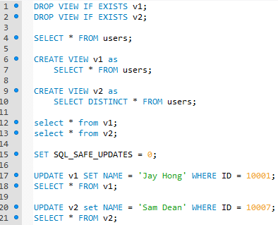

This is the initial state of v1

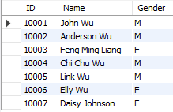

This is the initial state of v2

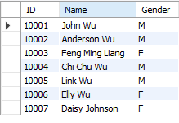

This is the state of v1 after the update

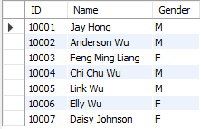

This is the state of v2 after the update

